INDEXALYZER TM Webinar Marketing
Invite Email #1
SUBJECT LINE: And the best performing index is…

Meet the tool that makes you the

smartest person in the room!

With Indexalyzer, discover the complete resource for all FIA crediting method performance. See the true performance on all indexes and take the headache out of helping your clients select strategies.

Live Webinar
<<enter date here>>
<<enter time here>>

Register Here >>

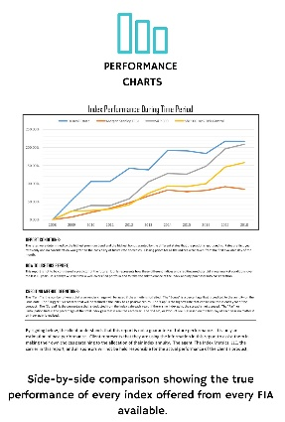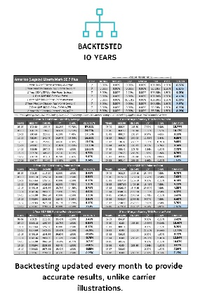
"Just last week, I used the indexalyzer and closed a $300,000 case. Its competitive intelligence allowed me to beat a competitor on a sale I wouldn't have otherwise made."
- Steve W. (Mesa, AZ)

REGISTER NOW >>

Text Blast Invite #1
WEBINAR ANNOUNCEMENT! <<enter date & time>> Learn about a new tool to help you sell more Indexed Annuities! www.indexresourcecenter.com/<<YOUR FMO>>webinars
2 Week Reminder
SUBJECT LINE: INDEXALYZER Webinar you signed up for is in 2 Weeks!
Just a friendly reminder that the webinar you signed up for is in 2 Weeks! If you haven’t done so already, mark your calendar! We will be showing you how to take the mystery out of Fixed Indexed Annuity crediting method allocations, AND HOW YOU CAN USE THIS INFORMATION TO INCREASE YOUR SALES!
The webinar information is listed below:
<<insert link with date and time>>
Invite Email #2
SUBJECT LINE: This tool closed a $300,000 case that the agent could not get closed for years!
Didn't it seem like there was a new annuity introduced every week in 2018?
Not only that, every annuity also comes with a new proprietary index.
In the FIA space, there are hundreds of annuities.
Within the hundreds of annuities, there are 66 total indexes that your client can benefit from.
S&P 500, Morgan Stanley TEBI, Janus MC Mkt Consensus...the list goes on and on.
So which ones perform the best?
Well, if you look at illustrations, it will show you the most recent 10 years.
Minor problem: not all annuities are sold in January. 1 month can make a major shift in market conditions (see: December 2018).
Good news for you: we got our hands on a tool unlike any other.
Instant analysis of all 55 indexes. Now you can truly show your client which is the best product.
We recently had an agent close a $300,000 sale using this tool.
Join us on our live webinar on <<enter date>> at <<enter time>> to see how this tool will change the way you look at selling annuities.
Click here to sign up. This <<enter date>> <<enter time>>.
I will look forward to seeing you there.
Regards,

<<enter your name>>

Text Blast Invite #2
Which index annuity has the best performance? Want to know? Join our webinar on <<enter date & time>> www.indexresourcecenter.com/<<YOUR FMO>>-webinars
1 Week Reminder
SUBJECT LINE: INDEXALYZER Webinar you signed up for is in 1 Week!
Wow, we are getting in multiple reports from agents using the INDEXZLYZER reports to help them close some big cases. This may be the webinar that truly changes your business! It starts in 1 week. If you haven’t marked your calendar, set an alert on your phone or even asked your partner to remind you, do so now! We are looking forward to having you there on <enter date & time>>.
Invite Email #3
SUBJECT LINE: How do you explain the 66 different indexes in FIA’s?
Imagine having an updated historical performance report on every FIA you sell, at your fingertips! Could you sell more? Could you be more confident in explaining the need for FIA’s? Would you be more compliant and a better fiduciary if you had actual data to show a client at application time so they can make better informed decisions about how to allocate their annuity? All these questions will be answered on <enter date & time>> at our Webinar introducing INDEXALYZER! The link for the webinar is below:
<<enter link>>
Webinar Next Tuesday (or the weekday of your webinar)
SUBJECT LINE: INDEXALYZER Webinar you signed up for is next <<enter weekday>>!
You only have a few more days to wait! Clear your calendar for next <<enter weekday>> at <<enter webinar time>>! You will be amazed at what this tool can do for your:
- New Sales
- Existing Clients
- Protecting Your Agency
- Marketing Efforts
We will talk to you then!
Webinar Tomorrow
SUBJECT LINE: INDEXALYZER Webinar you signed up for is TOMORROW!!!
We suggest you log in 10 minutes before the start of the webinar so you can have time to deal with any technical difficulties you may experience. Our guest speaker is Kent Jacquay. He is the founder of the Index Resource Center LLC and a 23-year veteran of Fixed Indexed products. We are so fortunate to have him scheduled for this webinar. He is going to walk you through his amazing Fixed Indexed annuity performance reports. You will learn:
- How to read them
- How to use them in a sales presentation
- Why they can protect your agency
- How to use them in marketing programs
See you tomorrow….
Webinar at ??:?? O’Clock Today
SUBJECT LINE: INDEXALYZER Webinar you signed up for is TODAY!!!
DON’T FORGET!!! The webinar starts in a few hours. Clear your schedule of last-minute fires. Pour yourself a hot cup of Joe (or whatever you are drinking today) and sit back and learn about this incredible new tool!
Text Blast Reminder
INDEXALYZER Webinar starts at <<enter time>> today! www.indexresourcecenter.com/<<YOUR FMO>>-webinars
Thank You For Attending (Existing Agents)
SUBJECT LINE: Thank You for attending today’s INDEXALYZER Webinar!
At <<YOUR FMO>> we strive to bring you valuable content and sales tools. We believe that this is one of the best tools we have ever seen. To get signed up with your subscription go to:
www.indexalyzer.com
Click the “Sign Me Up” link in the middle of the page. Be sure to select the <<YOUR FMO>> link to begin your sign-up process. Don’t forget to click the link for the Have a coupon? Click here to enter your code. Use the code:
EBS1610 (Click “Apply Code”)
This will get you the discount we talked about.
Thanks!
<<enter your name>>
Thank You For Attending (Prospective Agents)
SUBJECT LINE: Thank You for attending today’s INDEXALYZER Webinar!
At <<YOUR FMO>> we strive to bring our agents valuable content and sales tools. We believe that this is one of the best tools we have ever seen. To get signed up with your subscription go to:
www.indexalyzer.com
Click the “Sign Me Up” link in the middle of the page. Be sure to select the <<YOUR FMO>> link to begin your sign-up process. Don’t forget to click the link for the Have a coupon? Click here to enter your code. Use the code:
EBS1610 (Click “Apply Code”)
This will get you the discount we talked about.
We would love to talk to you more about bringing your business to <<YOUR FMO>>. This tool is only one of the many advantages you will have working with us. Call us today at <<YOUR PHONE NUMBER>> to talk more and to see what else we can show you from INDEXALYZER, maybe a Top 25 report for products offered in your state?
Thanks!
<<enter your name>>
Sorry We Missed You
SUBJECT LINE: Sorry we missed you today on the INDEXALYZER Webinar!
Wow! What a great webinar! Our agents asked several questions and showed an amazing amount of interest in INDEXALYZER! Don’t worry, we know things come up! Because of the incredible response, we are doing this again on <<enter date & time of next webinar>>. The link for this next webinar is below:
<<enter link>>
Hope to see you then!
<<enter your name>>

